

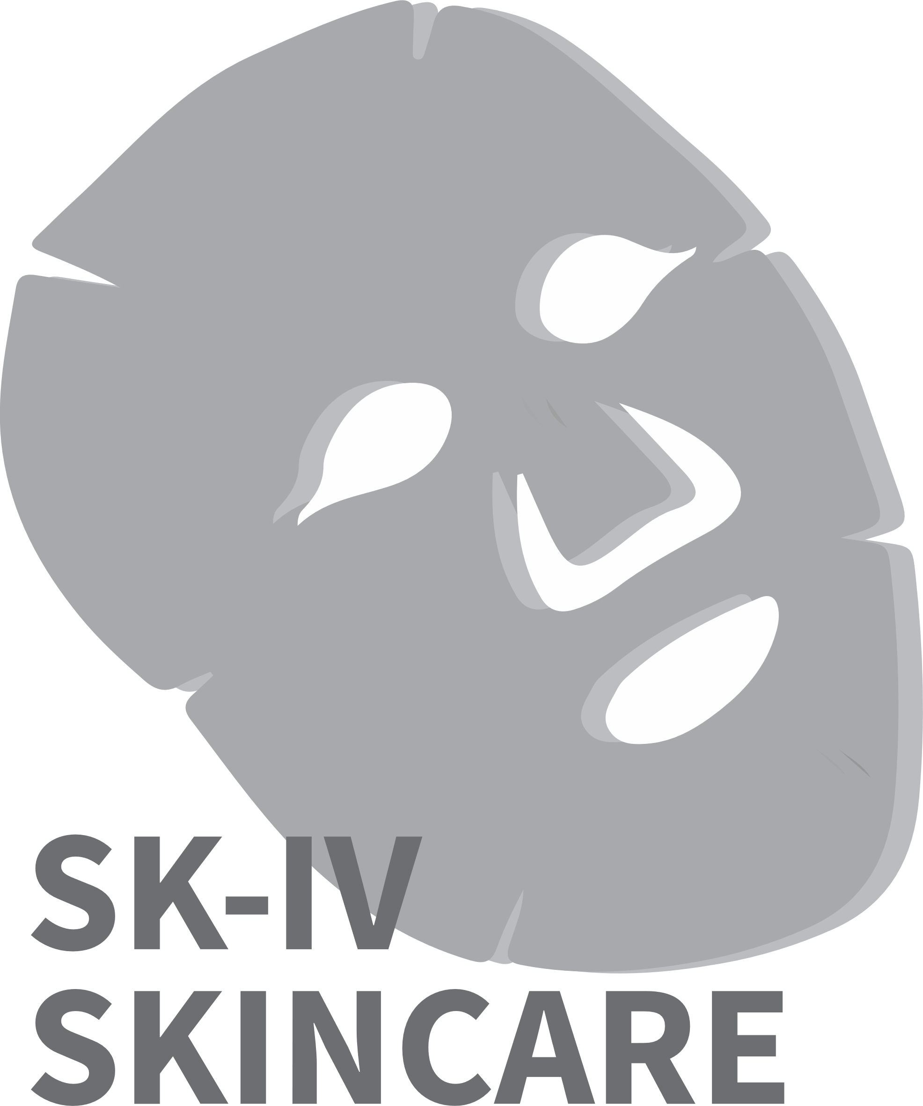

40.014 Engineering Systems Architecture

**Term 5 Spring, 2021**

**26/3/2021**

**Project Theme: Skin Care**

**Team 20: SK-IV Skincare**

|  |  |
| --- | --- |
| Sarah Wong (1004659) | Chan Yan Ling (1004406) |
| Lee Min Shuen (1004244) | Samuel Sim Wei Xuan (1004657) |
|  |  |